**Installation and user’s manual for the   
“Free Waveform (FWF) diffusion MRI” pulse sequence**

*Scope*

This document provides a very brief user manual to the FWF pulse sequence. For detailed information, please contact the author or find further information at the sequence resource page:

<https://github.com/filip-szczepankiewicz/fwf_seq_resources>

*Introduction*

The FWF sequence is based on the diffusion-weighted spin-echo diffusion encoding sequence (ep2d_diff). It replaces the trapezoidal diffusion encoding waveforms and replaces them with an arbitrary waveform (Fig. 1). The waveforms are compiled into the sequence files (.dll and .so) and are designed to yield linear, planar or spherical b-tensor encoding.



Fig. 1 – Schematic spin-echo sequence and its timing variables. The gradient waveforms are executed between the excitation pulse, refocusing pulse, and echo-planar readout. The timing variables show the maximal time available for encoding (Tpre and Tpost), the duration of each gradient waveform (δ1 and δ2), the gradient waveform separation (Δ), the duration of the refocusing block including the crushers (T180), the total encoding time (Tenc), and the echo time (TE). The balance gradient (red) is executed at the same time as the first crusher. The Stejskal-Tanner and FWF gradients are shown together for visual reference but are not executed simultaneously in practice. Image adapted from [1].

*Functionality*

The pulse sequence uses free gradient waveforms to yield tensor-valued diffusion encoding to enable methods such as diffusional variance decomposition (DIVIDE) and q-space trajectory imaging (QTI). The pulse sequence maintains all native functions such as:

* online image reconstruction
* export to DICOM
* simultaneous multislice (SMS)
* fat saturation
* inversion pulses

Additionally, the FWF sequence has the following features:

* replaces the monopolar encoding scheme with tensor-valued diffusion encoding
* gradient waveforms are pre-defined and numerically optimized for Prisma performance [2]
  + The waveforms are compatible with other scanners but may be less optimal
* the waveforms produce linear, planar or spherical b-tensors at b-values up to 2 ms/µm²
* gradient waveforms are compensated for concomitant gradient effects [2]
* gradient waveforms are automatically scaled in time and amplitude to maintain
  + the requested b-values
  + spin echo condition
  + and maxwell compensation
* b-tensors can be scaled and rotated arbitrarily by supplying a diffusion vector set (.dvs)
* the sequence allows native export of magnitude and phase data to DICOM
* all novel/necessary experimental parameters and waveforms are stored in the CSA header and can be extracted from the DICOM files using our open source tools

*Installation of sequence*

The installation of the pulse sequence follows the regular methodology. Briefly, the steps include:

1. [Only at XA-systems and later] Install the certificates using the default methodology.
2. Copy the provided pulse sequence files (.dll and .so) to the customer sequence folder (%CustomerSeq%). Note that you do not need any additional waveform files; the pre-defined waveforms are included in the pulse sequence files.
3. Import the sequence into the DOT editor (main interface on host computer) by dragging it from the default customer sequence “folder”.

*Sequence file naming convention*

The name of the sequence folder contains information about its version and compatibility. The convention is as follows:

[IDEAVERSION][*_SERVICEPACK][_SEQNAME][_VERSION and VARIANT][_COMPILEDATE (yymmdd)][*_COMMENT]

The asterisk denotes optional components.

*First use of FWF sequence*

**Note: Most situations require that the sequence be set up from the default settings, as opposed to importing settings from a DICOM or exar1-files!**

1. Load the sequence into the sequence editor. Check that the loaded sequence states that ‘a_ep2d_diff_fwf_simple’ is running by hovering the cursor over the sequence type (normally seen as the string ‘epse’ in the upper right corner, see green square in Figure 2).
2. To engage the additional FWF functions, select the [Diff]-tab, and set the ‘Diffusion Scheme’ to ‘Monopolar’, instead of ‘Bipolar’ (see red square in Figure 2). When the ‘Monopolar’ encoding type is selected, the FWF sequence is engaged, and it replaces the default monopolar Stejskal-Tanner sequence. To run the original monopolar version, please use the product sequence from the sequence library.
3. Go to the [Sequence] – [Special] – tab. All FWF-specific functionality is controlled from this tab. Conventional controls, such as setting the b-values, are unchanged. The special tab should look as in Fig. 3. If the parameter ‘MaxBVal’ is zero, something is wrong, and the sequence should not be executed!
4. Change the default b-value (default is zero, see purple box in Fig. 2) and test the sequence on a water phantom.
   1. It is a good idea to start slow, so start by testing the sequence at longer TE and/or low b-values.
   2. To verify that the gradient waveform is scaled properly and generates the correct b-value, you can measure the ADC in a water phantom. You can turn on the ADC map calculation to do this directly on the scanner.
   3. To verify that there are no issues with concomitant gradients, test the sequence in an oil phantom (or anything with a very low diffusivity) and note if there is a subtle loss of signal as a function of direction at the high b-values (see ref [2]).

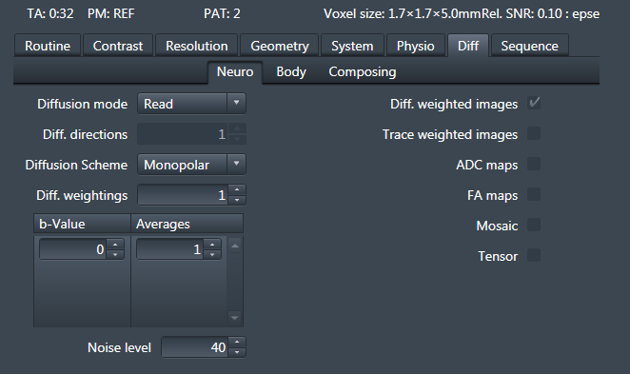

Fig. 2 – Select the “monopolar” diffusion scheme to engage the FWF sequence (red box). Set the b-value(s) and averages using the same methodology as for the product sequence (purple box).

*The* [Sequence] – [Special]-*tab*

The [Sequence] – [Special]-tab (Figure 3) contains all new functionality; standard functions are unaltered. NOTE: additional information is available in the tool-tips that appear when hovering over the parameter selectors. If these do not work (known issue), the default log contains all relevant information about how the FWF sequence is performing. To find the relevant section in the log, search for “galore”. Figure 3 shows an example of the interface that is used to control the FWF functions. Hover over the ‘MaxBVal’ value to get comprehensive sequence info, and hover over either of the duration parameters (*Dur) to see the timing of the sequence.

In the “simple” variant of the FWF sequence, the only parameter that can be changed is the shape of the b-tensor. The drop-down menu allows for selection of linear, planar, and spherical encoding (LTE, PTE, STE). Variants of the waveforms may be present for specific applications. Note that these are not equally efficient and may require different encoding times (and echo times etc.) to reach a given b-value.

*Hints*

1. To get some useful information about the sequence, its timing, and the hardware specifications, you can hover the cursor over the parameters in the special tab.
2. Do not run the waveforms at a maximal gradient amplitude (max possible b-value or minimal echo time). Try to leave approximately 5 mT/m headroom. This can be done by adding a few milliseconds to the minimal echo time.
3. Do not set the TE or TR at their minimal values since future software updates may change these slightly and force a change in an ongoing study.
4. Comprehensive information about the sequence is available in the real-time logging of the system. In the log-viewer, search for the keyword “galore”, to find the FWF-specific info.
5. Start by setting up the most challenging waveform (the one that yields the lowest b-value for a given setup) and use identical imaging parameters for all the other exam cards and b-tensor shapes. In other words, each exam card should only differ in what waveforms is used and what sampling scheme (dvs-file) is executed!

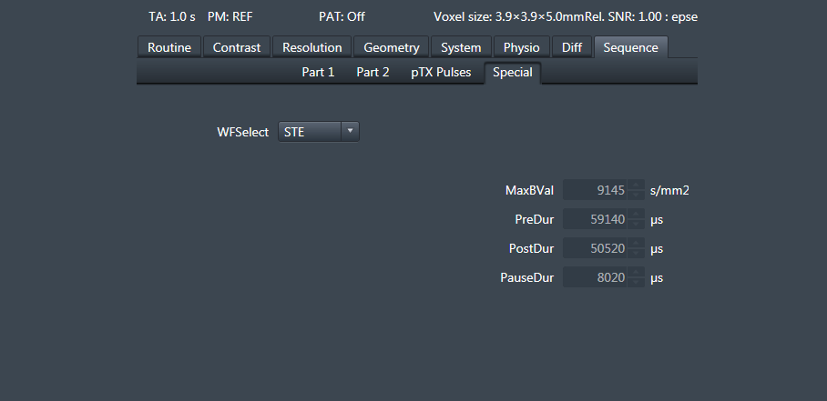

Fig. 3 – Example of the [Special]-tab in the simple sequence. When the sequence is set to ‘Monopolar’, this tab will be active and updated.

*Example setup at a Prisma system*

Setup the imaging protocol (these are a good starting point for whole-brain imaging).

* FOV = 220x220x120 mm3
* Matrix = 110x110
* 30-50 Slices
* Resolution
  + 2×2×4 mm3
  + 2.3×2.3×2.3 mm3
* TE ≈ 85
  + Minimal value + 4 ms to create headroom
* Partial Fourier = 6/8
* iPAT = 2 (GRAPPA)
* Bandwidth 1800 Hz/pix
* *b* = .1, .7, 1.4, and 2 ms/µm2 
  + Avoid using b = 0 images in analysis
  + See reference for data quality comparison [3]
* Num. diff. dirs = 6, 6, 12, 16 for linear encoding.
  + The same number of samples can be used for PTE or STE too
  + More directions can be added, starting from the outer shells
  + See resources below for sampling schemes

*Resources*

Main resource page contains waveform definitions, sampling schemes and links to other useful tools:

<https://github.com/filip-szczepankiewicz/fwf_seq_resources>

Extraction of FWF-specific header information from DICOM images:

<https://github.com/filip-szczepankiewicz/fwf_sequence_tools>

Review paper of how to design FWF experiments and their pitfalls, ref [4]:

<https://www.sciencedirect.com/science/article/pii/S0165027020304301>

Example protocols and sampling schemes from ref [3]:

<https://github.com/filip-szczepankiewicz/Szczepankiewicz_PONE_2019>

Analysis software, ref [5]:

<https://github.com/markus-nilsson/md-dmri>

*References*

1. Szczepankiewicz, F., *Imaging diffusional variance by MRI: The role of tensor-valued diffusion encoding and tissue heterogeneity*, in *Department of Medical Radiation Physics*. 2016, Lund University.

2. Szczepankiewicz, F., C.F. Westin, and M. Nilsson, *Maxwell-compensated design of asymmetric gradient waveforms for tensor-valued diffusion encoding.* Magn Reson Med, 2019.

3. Szczepankiewicz, F., et al., *Tensor-valued diffusion encoding for diffusional variance decomposition (DIVIDE): Technical feasibility in clinical MRI systems.* PLoS One, 2019. **14**(3): p. e0214238.

4. Szczepankiewicz, F., C.F. Westin, and M. Nilsson, *Gradient waveform design for tensor-valued encoding in diffusion MRI.* J Neurosci Methods, 2021: p. 109007.

5. Nilsson, M., et al. *An open-source framework for analysis of multidimensional diffusion MRI data implemented in MATLAB*. in *Proc. Intl. Soc. Mag. Reson. Med. 26*. 2018. Paris, France.